**“Production Management System”**

**for**

**Studio Sunna**

**Letter of transmittal**

November, 2017

Md. Saidur Rahman

Faculty of Department of Computer Science andEngineering

International University of Business Agriculture and Technology

Uttara, Dhaka-1230

Dear Sir,

Thank you for assigning us such an opportunitytoimplement this project. We have tried our best to make the project successful on time although there were some limitations. After completing all the jobs we have written this report, which will help you to know about our project. It is expected that the report focus on Integration of **Product Management System** Software.

I hope you will find the report relevant and meaningful.

Sincerely,

Md. Erfan Ullah Bhuiyan

ID: 15103325

On behalf of

Team Debugger

**Abstract**

This project is mainly developed for the project requirement of course CSC 387 of IUBAT University to ensure the development skill of knowledge. The purpose is to keep the record of clients, products, sales of Studio Sunna. Updating information is also possible in this software. Overall, consumption of time and energy, better security are the main aim of this project.

**Acknowledgement**

In the name of ALLAH, who is the most merciful and the most graceful.

First of all we sincerely would like to pay our gratitude to our project advisor Md. Saidur Rahman, faculty of Department of Computer science & Engineering, IUBAT University, who has given us the opportunity to make such a report for not only in this semester but also throughout our educational life at real sectors bygiving his valuable suggestions and advices at anytime, at any situation. We were able to make this report effectively and properly only for his right direction. Beside that we again like to thank him to give us an opportunity to submit this report.

**Declaration**

We, the students of BSc in Computer Science and Engineering of IUBAT University declaring that, this report on the topic of "Product Management system" has been prepared for the fulfillment of the project of course CSC 387.

The report and the project on "Product Management system" are originally prepared by Team Debugger. All module and procedure of this project is being made after proper inspection and internet information.

It has not been prepared for any other purposes, rewards or presentations.

----------------------------------------

Md. Erfan Ullah Bhuiyan

ID:15103325

On behalf of

Team Debugger

**Letter of authorization**

01 November, 2017

Team Debugger

IUBAT University

BSc in CSE

Dear Team Debugger,

I, hereby, authorized you to develop "Product Management System"to fulfill the requirement of the project of course CSC 387.

I wish you to complete this project successfully.

-------------------------------------

Md. Saidur Rahman

Faculty of Department of Computer Science andEngineering

International University of Business Agriculture and Technology

Uttara, Dhaka-1230

**"Content Page"**

1. INTRODUCTION

1.1. Introduction of Project

1.2. Aim of Project

1.3. System Study & Analysis

1.3.1. System Analysis

1. EXISTING SYSTEM

2.1. Existing Manual System

2.2. Problems with Existing System

1. PROPOSED SYSTEM

3.1. Aim of Proposed System

3.1.1. Advantage of the Proposed System

3.2. System Feasibility Study

1. PROPOSED SYSTEM DESIGN

4.1. Logical Design

4.2. Physical Design

4.3. Design /Specification Activities

1. IMPLEMENTATION OF MODEL

5.1. Analysis Modeling & Design Methodologies

5.1.1. Database Design

5.1.2. Entity Relationship Model

5.1.3. Identifying Entities

5.1.4. Entity Relationship Diagram

5.1.5. Relationship Cardinality

5.1.6. Entity Relationship Diagram (Diagram)

5.1.7. Database Table Structure

5.2. System description

5.2.1. Data Flow Diagram (Introduction)

5.2.2. Symbol of DFD

5.2.3. DFD of Project

5.2.4. Effort Distribution

5.2.5. Task Distribution

5.2.6. Time Chart for Activities

5.2.7. Project Cost Estimation

5.2.7.1. Hardware Costs

5.2.7.2. Software Costs

5.2.7.3. Other Costs

5.3. System Testing

5.3.1. Introduction

5.3.2. Test Plan

1. SYSTEM REQUIREMENTS & USING GUIDELINE

6.1. System Requirements

6.1.1. Hardware Requirements

6.1.2. Software Requirements

6.2. Using Guideline

6.3. Screen Shoot

1. CONCLUSION

**1. INTRODUCTION**

**1.1. Introduction of project**

The Production Management System keeps the day by day record of Studio Sunna. It can keep the information of clients, products, orders, sales, financial records. In system data can be stored on database of the company. The exciting part of this project is; it displays client information, statistical summary of monthly and yearly cost, benefit report . It can consume time as well as energy.

**1.2. Aim of project**

In the existing system the storing data is done only manually paper-pan based system but in our proposed system we have to computerize all the processing information using the Product Management System. All sort of information is managed by an admin and that is the reason of our main system.

**1.3. System Study & Analysis**

**1.3.1. System Analysis**

System analysis is a process of gathering and interpreting facts, diagnosing problems and the information to recommend improvements on the system. It is a problem solving activity. that requires intensive communication between the system users and system developers. System analysis or study is an important phase of any system development process. The system is studied to the minutest detail and is the system analyst plays the role of the interrogator and dwells deep into the working of the present system. The system is viewed as a whole and the input to the system are identified. The outputs from the organization are traced to the various processes. System analysis is concerned with becoming aware of the problem, identifying the relevant and decisional variables, analyzing and synthesizing the various factors and determining an optimal or at least a satisfactory solution or program of action.

A detailed study of the process must be made by various techniques like interviews, questionnaires etc. The data collected by these sources must be scrutinized to arrive to a conclusion. The conclusion is an understanding of how the system functions. This system is called the existing system. Now the existing system is subjected to close study and problem areas are identified. The designer now functions as a problem solver and tries to sort out the difficulties that the enterprise faces. The solutions are given as proposals. The proposal is then weighed with the existing system analytically and the best one is selected. The proposal is presented to the user for an endorsement by the user. The proposal is reviewed on user request and suitable changes are made. This is loop that ends as soon as the user is satisfied with proposal.

Preliminary study is the process of gathering and interpreting facts using the information for further studies on the system. Preliminary study is problem solving activitythat requires intensive communication between the system users and system developers. It does various feasibility studies. In these studies a rough figure of the system activities can be obtained, from which the decision about the strategies to be followed for effective system study and analysis can be taken.

**2. EXISTING SYSTEM**

**2.1. Existing Manual System**

In the existing system the storing of information is done only manually paper-pen based system. People are using file folder and different types of bookshelf to store the information. Sometimes they get damage due to get old and can be lost as well. Also for calculation they use calculators and hand written receiving letter. If it is necessary to find some information about client or product then they have to search different document from different places.

**2.2. Problems with Existing System**

* Lack of security of data.
* More man power.
* Time consuming.
* Needs manual calculations.
* No direct role for the higher officials.
* Possibility to Lost of information

To avoid all these limitations and make the working more accurately the system needs to be computerized.

**3. PROPOSED SYSTEM**

**3.1. Aim of Proposed System**

The aim of proposed system is to develop a system of improved facilities. The proposed system can overcome all the limitations of the existing system. The system provides proper securityand reduces the manual work.

**3.1.1. Advantage of the Proposed System**

The system is very simple in design which is very user friendly and easy to implement. The system requires very low system resources and the system will work in almost all configurations. It has got following features:

* Security of data
* Ensure data accuracy.
* Proper control of the higher officials.
* Minimize manual data entry.
* Minimum time needed for the various processing.
* Greater efficiency.
* Better service.
* User friendliness and interactive.
* Minimum time consumption.

**3.2. System Feasibility Study**

Feasibility study is made to see if the project on completion will serve the purpose of the organization for the amount of work effort and the time that spend on it. Feasibility study lets the developer foresee the future of the project and the usefulness. A feasibility study of a system proposal is according to its work ability; which is the impact on the organization, ability to meet their user needs and effective use of resources. Thus when a new application is proposed it normally goes through a feasibility study before it is approved for development. The document provides the feasibilityof the project that is being designed and lists various areas that were considered very carefully during the feasibility study of this project such a Technical, Economic and Operational feasibilities. The following are its features:

**Technical Feasibility**

The system must be evaluated from the technical point of view first. The assessment of this feasibility must be based on an outline design of the system requirement in the terms of input, output, programs and procedures. Having identified an outline system, the investigation must go on to suggest the type of equipment, required method developing the system, of running the system once it has been designed.

Technical issues raised during the investigation are:

Does the existing technology sufficient for the suggested one?

Can the system expand if developed?

The project should be developed such that the necessary functions and performance are achieved within the constraints. The project is developed within latest technology. Through the technology may become obsolete after some period of time due to the fact that never version of same software supports older versions, the system may still be used. So there are minimal constraints involved with this project. The system has been developed using C# the project is technically feasible for development.

**Economic Feasibility**

The developing system must be justified by cost and benefit. Criteria to ensure that effort is concentrated on project, which will give best, return at the earliest. One of the factors, which affect the dev e I o pm e rat of a new system, is the cost it would require.

The following are some of the important financial questions asked during preliminary investigation:

The costs conduct a full system investigation.

The cost of the hardware and software.

The benefits in the form of reduced costs or fewer costly errors.

Since the system is developed as part of project work, there is no manual cost to spend for the proposed system. Also all the resources are already available, it give an indication of the system is economically possible for development.

**Operational Feasibility**

This includes the following questions:

Is there sufficient support for the users?

Will the proposed system cause harm?

The project would be beneficial because it satisfies the objectives when developed and installed. All behavioral aspects are considered carefully and conclude that the project is behaviorally feasible.

**4. PROPOSED SYSTEM DESIGN**

**4.1. Introduction**

Design is the first step into the development phase for any system. Design is a creative process. A good design is the key to effective system. The term "design" is defined as ''the process of applying various techniques and principles for the purpose of defining a process or a system in sufficient detail to permit its physical realization". It may be defined as a process of applying various techniques and principles for the purpose of defining a device, a process or a system in sufficient detail to permit its physical realization. Software design sits at the technical kernel of the software engineering process and is applied regardless of the development paradigm that is used. The system design develops the architectural detail required to build a system.

As in the case of any systematic approach, this software too has undergone the best possible design phase fine tuning all efficiency, performance and accuracy levels. System design goes through two phases of development: Logical and Physical Design.

**4.2. Logical design:**

The logical flow of a system and define the boundaries of a system. It includes the following steps:

1. We have reviewed the current physical system - its data flows, file content, volumes, frequencies etc of Sunna Studio.
2. Then we prepared output specifications which determine the format, content and frequency of reports.
3. Then prepared input specifications -format, content and most of the input functions.
4. After that we prepared edit, security and control specifications.
5. Finishing the four steps we started for the implementation plan.
6. So, we prepared a logical design walk through of the information flow, output, input, controls and implementation plan.
7. Finally we reviewed benefits, costs, target dates and system constraints.

**4.3. Physical design:**

Physical design produces the working systems by define the design specifications that tell the programmers exactly at the candidate system must do. It includes the following steps.

1. Designing the physical design for the system.
2. We specified input and output media.
3. Then designed the database and specified backup procedures.
4. We designed physical information flow through the system and a physical design walk through.
5. We planned the system implementation.
6. After that we determined training procedures, courses and timetable for the system.
7. After a test and implementation plan we specified any new hardware/software if needed.
8. Finally we updated benefits, costs, and conversion date and system constraints.

**4.4. Design/Specification activities:**

* Concept formulation.
* Problem understanding.
* High level requirements proposals.
* Feasibility study.
* Requirements engineering.
* Architectural design.

**5. IMPLEMENTATION OF MODEL**

**5.1. Analysis Modeling and Design Methodologies**

At a technical level, software engineering begins with a series of modeling tasks that lead to a complete specification of requirements and a comprehensive design representation for the software to be built. Analysis modeling uses a combination of text and diagrammatic forms to depict requirements for data function and behavior in a way that is relatively easy to understand and more important, straightforward to review for correctness, completeness and consistency. The analysis model is the first technical representation of a system.

There are a few analysis modeling methods but two of those models are widely used. They are- structured analysis and object oriented analysis (OOA). The object oriented analysis (OOA) model is used in our project. Because OOA is used when there are many transformation flows. As there are many transformation flows and few transaction flows in this system, object oriented analysis has been chosen.

**5.1.1. Database design**

A database is an organized mechanism that has the capability of storing information through which a user can retrieve stored information in an effective and efficient manner. The data is the purpose of any database and must be protected. The database design is a two level process. In the first step, user requirements are gathered together and a database is designed which will meet these requirements as clearly as possible. This step is called Information Level Design and it is taken independent of any individual DBMS. In the second step, this Information level design is transferred into a design for the specific DBMS that will be used to implement the system in question. This step is called Physical Level Design, concerned with the characteristics of the specific DBMS that will be used:

Data Integrity

Data independence

To decrease the searching time we tried to make the database such a way that table can be create dynamically fully controlled by the application. So it will be easier to search and consume less time which also support Normalization. Normalization is the process of decomposing the attributes in an application, which results in a set of tables with very simple structure. The purpose of normalization is to make tables as simple as possible. Normalization is carried out in this system for the following reasons.

To structure the data so that there is no repetition of data, this helps in saving.

To permit simple retrieval of data in response to query and report request.

To simplify the maintenance of the data through updates, insertions, deletions.

To reduce the need to restructure or reorganize data which new application requirements arise.

**5.1.2. Entity Relationship model**

In software engineering, an Entity relationship model (ER model) is a data model for describing a database in an abstract way. An ER model is an abstract way of describing a database. In the case of a relational database, which stores data in tables, some of the data in these tables point to data in other tables- for instance, your entry in the database could point to several entries for each of the phone numbers that are yours. The ER model would say that you are an entityand each phone number is an entity, and the relationship between you and the phone numbers is 'has a phone number'. Diagrams created to design these entities and relationships are called entity-relationship diagrams or ER diagrams.

**5.1.3. Identifying Entities**

Identifying the entities according to our design:

1. User
2. Client
3. product
4. Order List
5. Sales Record

**5.1.4. Entity Relationship Diagram**

The Entity Relationship diagram (ERD) enables a software engineer to fully specify the data objects that are input and output from a system, the attributes that define the properties of these objects and their relationship. It provides an excellent graphical representation of the data structures and relationship. They provide a clear view of the logical structure of data within the boundary of interest and allow the engineer to model the data without considering the physical form.

Some of the basic terms used in ERD are described below:

**Entity**: An entity is an object with physical existence or may be an object with conceptual existence. For example a car, a student, an employee, an applicant. An entity is represented by a rectangle.

Entity of our system:

1. User
2. Client
3. product
4. Order List
5. Sales Record

**Attribute**: Attribute is a piece of information that describes a particular entity. An attribute is described by an oval.

Attribute of our system under every entity:

User:

1. ID
2. Password
3. Name

Client:

1. Address
2. Name
3. Phone_number
4. Company_name
5. Email
6. Cl_id
7. Job_position

Product:

1. Size
2. Name
3. Product_id
4. Weight
5. Cost
6. Color

Order List:

1. Order date
2. Delivery_date
3. Order_id
4. Selling_price
5. Quantity
6. Status
7. Cl_id
8. Product_id

Sales Record:

1. Sell_id
2. Selling_date
3. Quantity
4. Product_id
5. Profit
6. Order_id
7. Cl_id

**Relationship**: A relationship is a logical linkage between two or more entities which describes how the entities are associated with each other. A relationship is described by a diamond.

Relationship between the entities of our system:

1. Manage info: Between user and client

2. Mange: Between user and product

3. Get order: Between product and order list

4. Order: Between client and order list

5. Order delivery: Between sales record and order list

* + 1. **Relationship Cardinality**

Relationship Cardinality refers to the number of entity instances involved in the relationship. The cardinality ratios are:

* 1:1 (One to one): No one to one relationship in our system.
* 1:N (One to many): Between user and client, between user and product.
* N:N (Many to many): Between client and order list, between product and order list, between sales record and order list.

**Primary Key:** A primary key is an attribute or collection of attributes that allow us to identify an entity uniquely. Naturally an underline is used in attribute to identify primary key.

Primary key of our ERD: id, Cl_id, product_id, order_id, sell_id

**Foreign key**: A foreign key is an attribute of a relation which refers to an existing attribute of another relationship.

Foreign key of our ERD: Cl_id, order_id, product_id, order_date, product_cost

**5.1.6. Entity Relationship Diagram (Diagram)**

1

1

1

n

n

n

n

n

1

1

1

1

Sales Record

Order delivery

Order List

Product

Get order

order

User

Manage

Manage info

Client

**5.1.7. Database Table Structure**

Table: User

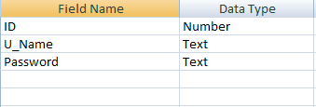

Table: Client

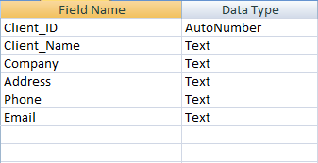

Table: Product

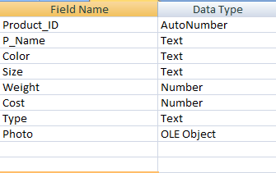

Table: Order List

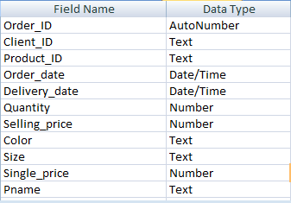

Table: Sales Record

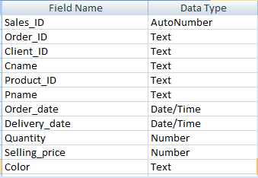

**5.2. System Description**

**5.2.1. Data Flow Diagram**

A data flow diagram is a graphical representation that depicts information flow and the transforms that are applied as data move from input to output. It is known as data flow graph or bubble chart. The DFD may be used to represent a system or software at any level of abstraction. DFD may be partitioned into levels that represent increasing information flow and functional detail. Therefore, the DFD provides a mechanism for functional modeling as well as information flow modeling.

A level of DFD, which is also known as fundamental system model or a context model, represents the entire software or system element into as a single bubble with input and output data indicated by incoming and outgoing arrows respectively. Then bubble of context model should be decomposed into several levels.

In DFD, there are four symbols that are given in the figure:

* A square defines a source or destination that is external entity of system data.
* An arrow identifies data flow that is data in motion. It is a pipeline through which information flows.
* A circle or a bubble represents a process that transforms incoming data flow(s) into outgoing data flow(s)
* An opera rectangle is a data store or a temporary repository of data.

**5.2.2. Symbol of DFD**

|  |  |
| --- | --- |
| **Description** | **Symbol** |
| Data flow |  |
| Source & Destination |  |
| Process |  |
| Data store |  |

**5.2.3. DFD of Project**

**Context Level Diagram**

0

Production Management System

Admin

Fig:Context Level Diagram

**Level 1 DFD**

1

Client

2

Products

Admin

Production Database

D1

3

Orders

4

Sales Record

5

Financial Reports

Fig: Level 1 DFD

**Level 2 of process 1**

1.1

|  |
| --- |
|  |

Client info Verify

Information store

Data from

Admin

D1

Production Database

Client Profile updated

1.2

Clarification of

Information

Report to Admin

Fig: Level 2 Diagram of process 1

**Level 2 of process 2**

Information store

2.1

Verify product details list

Product Information

From Admin

D1

Production Database

Product Profile updated

2.2

Check Information

Report to Admin

Fig: Level 2 Diagram of process 2

**Level 2 of process 3**

Store in database

Order Information

3.1

Verify Order information

From Admin

D1

Production Database

Order Profile updated

3.2

Check information

Report to Admin

Fig: Level 2 Diagram of process 3

**Level 2 of process 4**

Store in database

Data

4.1

Clarify the data

From Admin

D1

Production Database

Updated data

4.2

|  |
| --- |
|  |

Clarify the data

Report to Admin

Fig: Level 2 Diagram of process 4

**Level 2 of process 5**

Data to Store

Data from

5.1

Sell & cost record calculation

Admin

D1

Production Database

Data to Process

5.2

|  |
| --- |
|  |

Calculate Profit

Report to Admin

Fig: Level 2 Diagram of process 5

**5.2.4. Effort Distribution**

The software project estimation technique leads to estimate of work units required to complete the software development. A recommended distribution of effort across the definition and development phases is referred as the 40- 20-4 0 rule. Forty percent of all effort is allocated to front-end analysis and design, twenty percent is allocate d to coding and the remaining forty percent is allocated to back-end testing. This rule is used as a   
guideline only.

In this project, 45% of full software development has been allocated to analysis and design, 23% has been allocated to coding and the remaining 32% is allocated to software testing and support.

A detailed view of the effort distribution chart is illustrated below:

**5.2.5. Task Distribution**

Project scheduling is an activity of distributing the estimated efforts within the planned project duration. There are some basic rules for project scheduling. They are as follows:

* Compartmentalization- The project must be compartmentalized into a number of manageable activities and tasks.
* Interdependency- The interdependencyof each compartmentalized activity or task must be determined. Some tasks must occur in sequence while others can occur in parallel.
* Time allocation - Each task to be scheduled must be allocated some number of work units.

**5.2.6. Time Chart for Activities**

Total system development is a combination of set of tasks. These set of tasks should be done sequentially and timely. Project schedule works as the guideline of the supervisor Md. Saidur Rahman as system developer. The task chart of our system is given below:

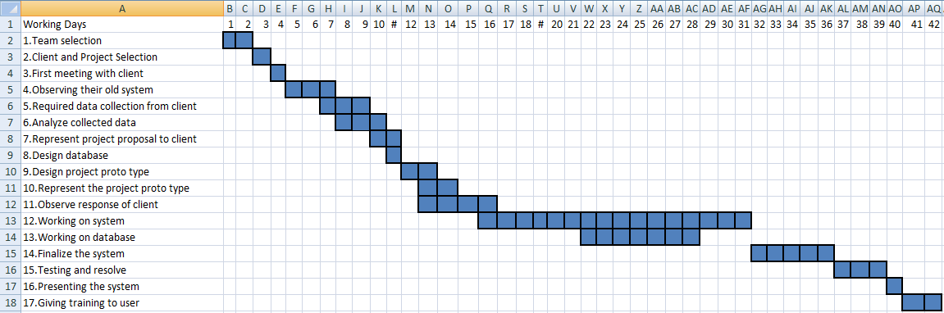

**5.2.7. Project Cost Estimation**

Cost estimation describes the expense that needs to spend during project development. The project cost estimation mostly based on:

* Hardware cost
* Software cost
* Other costs

**5.2.7.1. Hardware Costs**

Hardware Accessories Cost= 30900 tk

Hardware Accessories life= 36 Months

Hardware Accessories usage = 8 Months

Hardware Accessories use cost = (30900/36) *8 = 6869 tk

|  |  |  |  |  |  |  |  |
| --- | --- | --- | --- | --- | --- | --- | --- |
| **Machine** | **Quantity** | **Parts** | **Quantity** | **Price**  **(tk)** | **Depreciation** | **Depreciation cost(tk)** | **Hardware cost** |
| **Desktop Computer** | **1** | Motherboard | 1 | 4000 | (4000/36) *8 | 889 | **6869 tk** |
| Processor | 1 | 3500 | (3500/36) *8 | 778 |
| RAM(2GB) | 1 | 1800 | (1800/36) *8 | 400 |
| HDD(32GB) | 1 | 3000 | (3000/36) *8 | 667 |
| Monitor | 1 | 8000 | (8000/36) *8 | 1778 |
| DVD writer | 1 | 1600 | (1600/36) *8 | 356 |
| Keyboard, mouse, others | 1 | 1000 | (1000/36) *8 | 223 |
| **Printer** | **1** |  |  | 8000 | (8000/36) *8 | 1778 |
| **Total** |  |  |  |  |  |  | **6869 tk** |

**Fig: Hardware Cost Table**

**5.2.7.2. Software Costs**

Legal Licensed Software for system development:

Software Cost= 115 200 tk

Software licensed Validity= 12 Months

Software usage = 8 Months

Software use cost = (115200/12)*8 = 76800 tk

Total Software cost 76800 tk

|  |  |  |  |  |
| --- | --- | --- | --- | --- |
| Software Package | Price(tk) | Depreciation | Depreciation cost(tk) | Total |
| Microsoft Windows7(Professional) | 18400 | (18400/12)*8 | 12266 | 76798 tk |
| Microsoft Office | 16800 | (16800/12)*8 | 11200 |
| MS Visual Basic 6 | 16000 | (16000/12)*8 | 10666 |
| Crystal Report 9 | 24000 | (24000/12)*8 | 16000 |
| MS SQL Server | 40000 | (40000/12)*8 | 26666 |
| Total | | | | 76798 tk |

**Fig: Software Cost Table**

**5.2.7.3. Other Costs**

|  |  |
| --- | --- |
| **Description** | **Cost(tk)** |
| Electricity& other bill | 2000 |
| Electronic equipment & servicing | 6000 |
| **Total** | **8000** |

**Fig: Other Cost Table**

Total Estimation:

To develop this project the estimated cost is:

Hardware Cost: 6870 tk

Software Cost: 76800 tk

Others Cost: 8000 tk

Total: 91670 tk

* 1. **System Testing**

**5.3.1. Introduction**

Software Testing is the process of executing software in a controlled manner, in order to answer the question – “Does the software behave as specified?”. Software testing is often used in association with the terms verification and validation. Validation is the checking or testing of items, includes software for conformance and consistency with an associated specification. Software testing is just one kind of verification, which also uses techniques such as reviews, analysis inspections, and walkthroughs. Validation is the process of checking that what has been specified is what the user actually wanted.

Validation: Is this indentifying valid data?

Unit: Is any unit of system working correctly with all related data?

Integration: Are all unit of system working properly when unit combines?

Output : Are all outputs correct?

Software testing should not be confused with debugging. Debugging is the process of analyzing and localizing bugs when software does not behave as expected. Although the identification of some bugs will be obvious from playing with the software, a methodical approach to software testing is a much more thorough means for identifying bugs. Debugging is therefore an activity which supports testing, but cannot replace testing. Other activities which are often associated with software testing are static analysis and dynamic analysis. Static analysis investigates the source code of software, looking for problems and gathering metrics without actually executing the code. Dynamic analysis looks at the behavior of software while it is executing, to provide information such as execution traces timing profiles, and test coverage information.

Testing is a set of activity that can be planned in advanced and conducted systematically. Testing begins at the module level and work towards the integration of entire computers based system. Nothing is complete without to as it vital success of the system testing objectives, there are several rules that can serve as testing objectives. They are-

Testing is a process of executing a program with intend of finding an error. A good test case is one that has high possibility of finding an undiscovered error. A successful test is one that uncovers an undiscovered error. If a testing is conducted successfully according to the objectives as stated above, it would uncover errors in the software also testing demonstrate that the software function appear to be working according to the specification, that performance requirement appear to have been met.

There are three ways to test program.

=]

* For correctness
* For implementation efficiency
* For computational complexity

**5.3.2. Test Plan**

A test plan implies a series of desired course of action to be followed in accomplishing various testing methods. The Test Plan acts as a blue print for the action that is to be followed. The software engineers create a computer program, its documentation and related data structures. The software developers are always responsible for the individual units of the programs, ensuring that each performs the function for which it was designed. The specific objectives of testing should be stated in measurable terms. So that the mean time to failure, the cost to find and fix the defects, remaining defect density or frequency of occurrence and test work-hours per regression test all should be stated within the test plan.

The levels of testing include:

* Validation Testing
* Unit Testing
* Integration Testing
* Output Testing

Validation Testing: We imputed different types of value with different format. This software recognizes the correct format and accepts.

Unit Testing: Combination of input is perfectly works for each and every unit and we did not find any error which produce during combined and data from different table and calculation source.

Integration Testing: We took several attempt to find different types of result and calculation which will related all the sub part of our system where all the units and database are using in this system and found system is reliable.

**6. System Requirements & Using Guideline**

**6.1. System Requirements**

**6.1.1. Hardware Requirements**

* Mother Board : Intel Pentium D
* Processor : 1.0 GH7 Clock speed
* RAM : 512 MB or more
* Hard disk : 20 GB or more
* Monitor : VGA/SVGA
* Keyboard : 11:4 Keys
* Mouse : 2 buttons/ 3 buttons

**6.1.2. Software Requirements**

* Operating System : Windows 98/2000/XP/Vista/Windows 7
* Front-end : Visual Basic 6.0
* Back-end : MS Access / MS SQL Server
* Report : Crystal Report 9.0

**6.2. Using Guideline**

Once the system is successfully developed the next important step is to ensure that the administrators are well trained to handle the system. This is because the success of a system invariably depends on how they are operated and used. The implementation depends upon the right people being at the right place at the right time. Education involves creating the right at and motivating the user. The administrators are familiarized with the run procedures of the system, working through the sequence of activities on an ongoing basis.

Implementation is the state in the project where the theoretical design is turned into a working system. By this the users get the confidence that the system will work effectively. The system can be implemented only after through testing. The systems personnel check the feasibility of the system. The actual data were inputted to the system and the working of the system was closely monitored. The master option was selected from the main menu and the actual data were input through the corresponding input screens. The data movement was studied and found to be correct queries option was then selected and this contains various reports. Utilities provide various data needed for inventory was input and the module was test run. Satisfactory results were obtained. Reports related to these processes were also successfully generated.

Implementation walkthroughs ensure that the completed system actually solves the original problem. This walkthrough occurs just before the system goes into use, and it should include careful review of all manuals, training materials and system documentation. Again, users, the analyst and the members of the computer services staff may attend this meeting.

**Training Session**: For training purpose, we planned to make it familiar for the user. In this way it can be much easier to use and maintain.

**Training**: To make training where several topics included for the administrators which are, how to use, data backup, security arrangement, we will show the user how to use this Product Management System.

**6.3. Screen Shoot**

**Home**

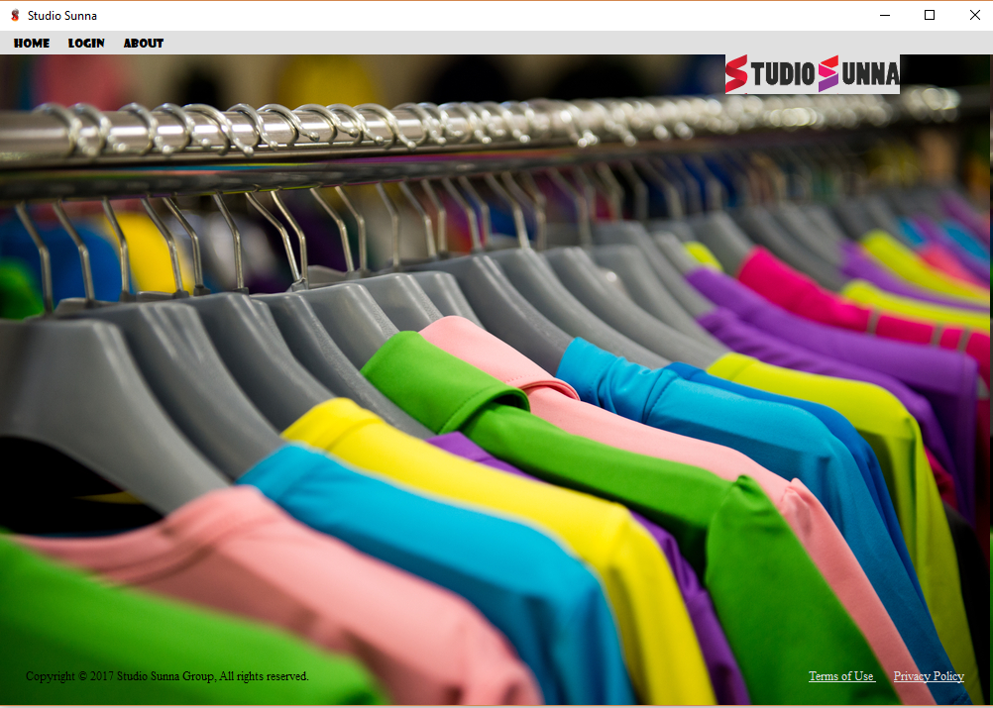

**Log In**

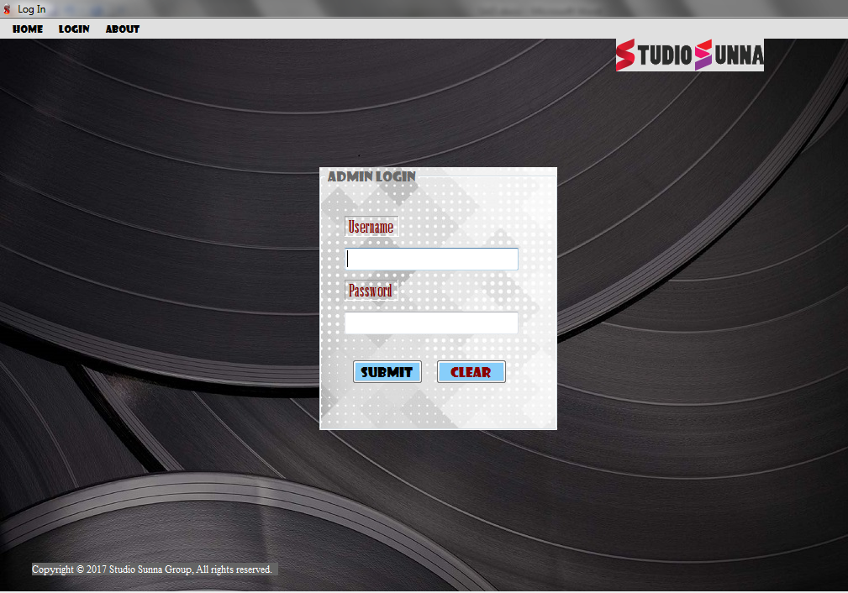

**Registration**

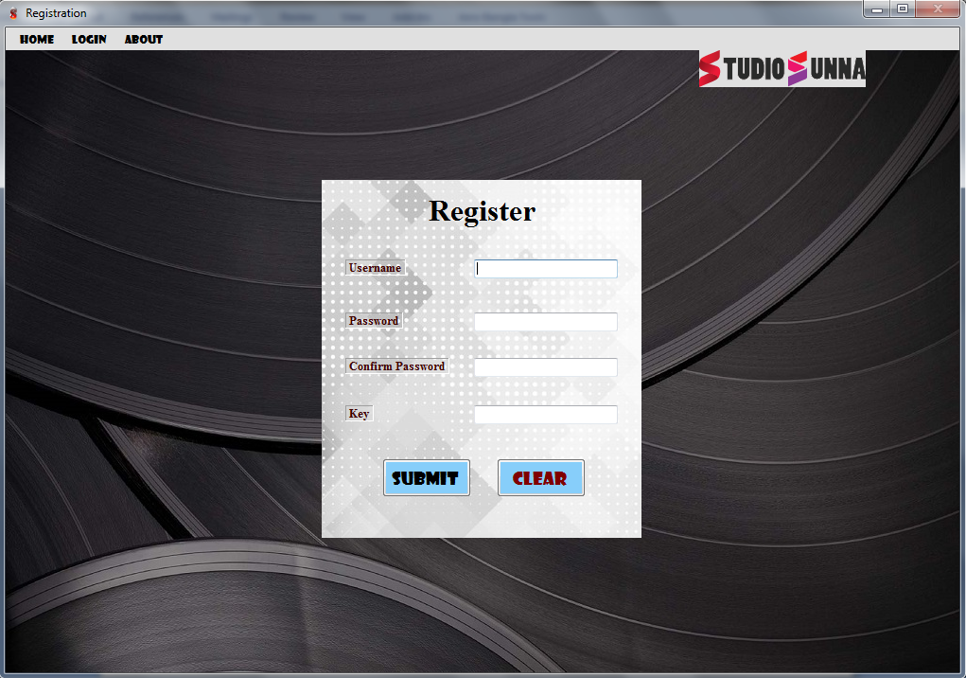

**About**

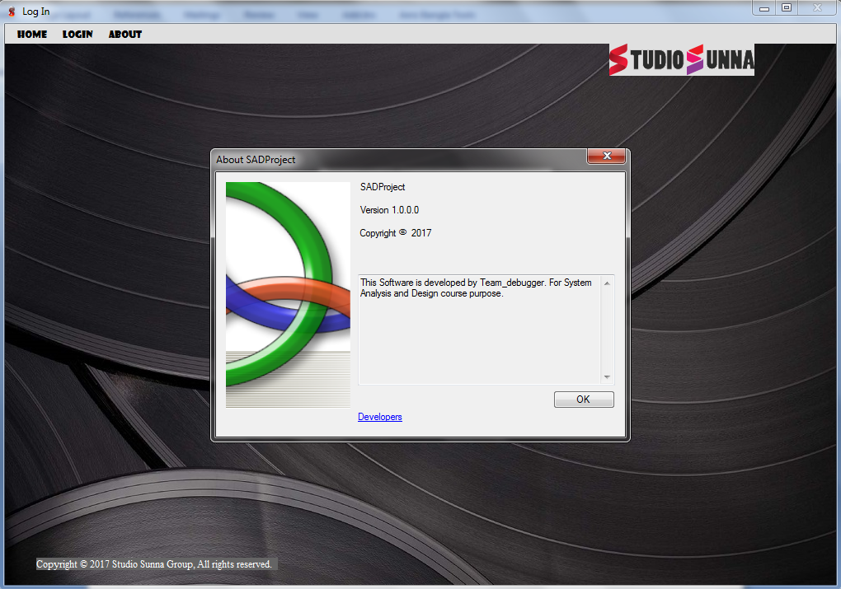

**About-Developer**

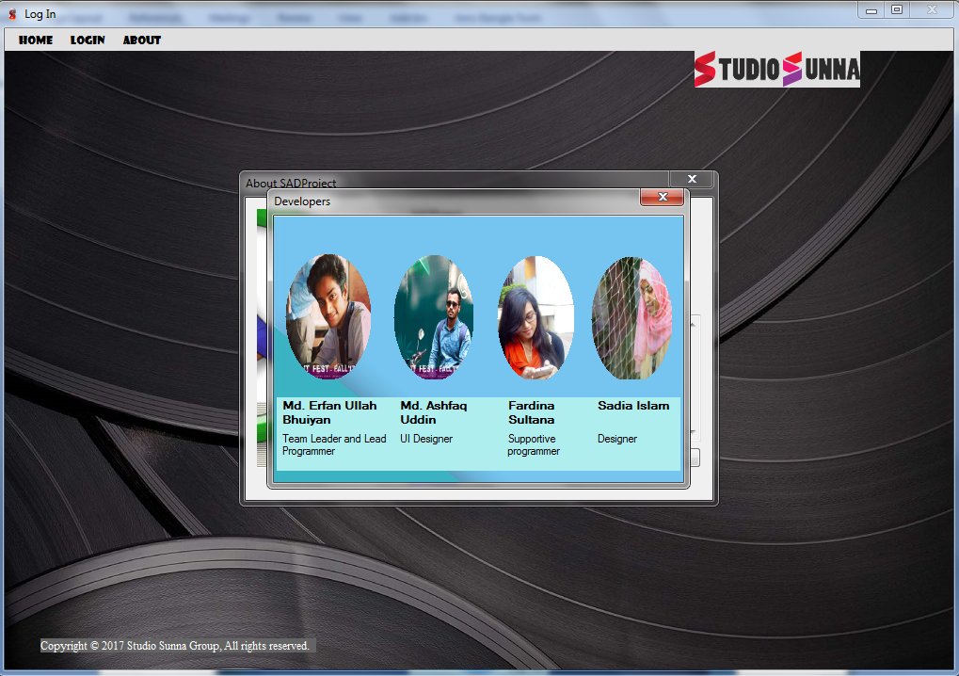

**Log In as Admin**

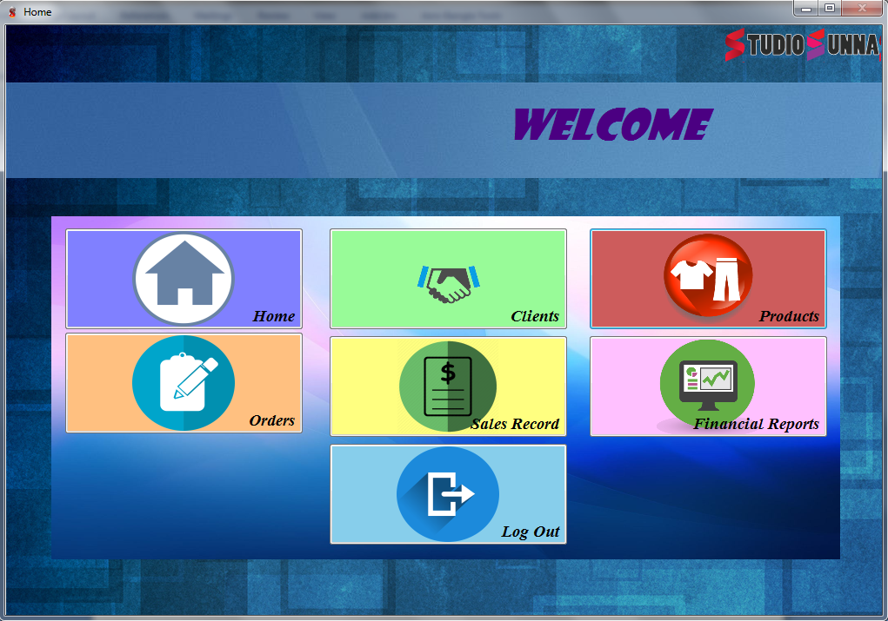

**Client**

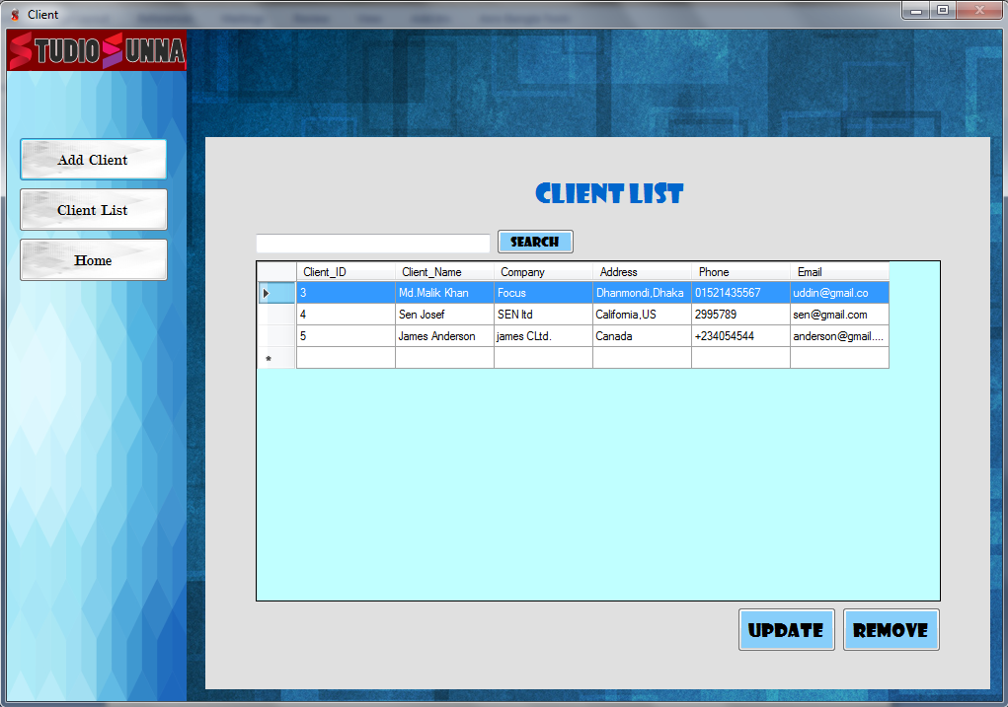

**Client-Add Client**

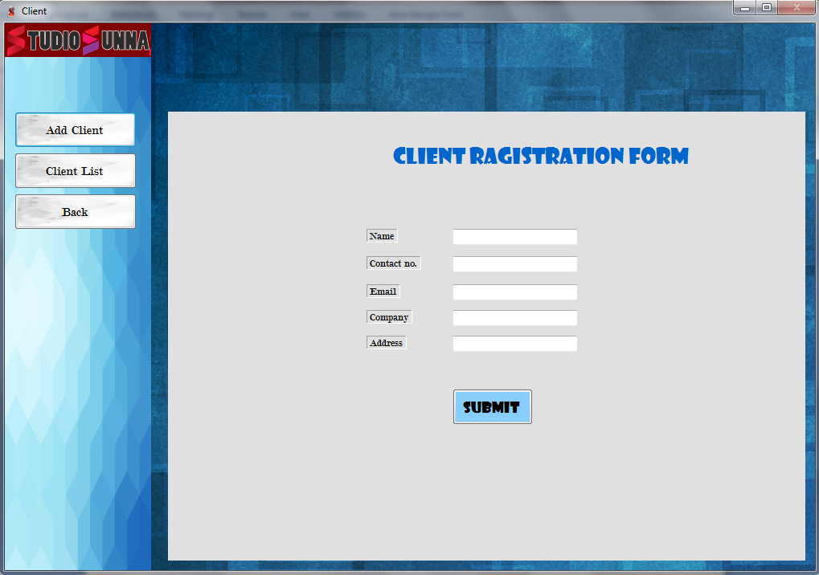

**Product-Product list**

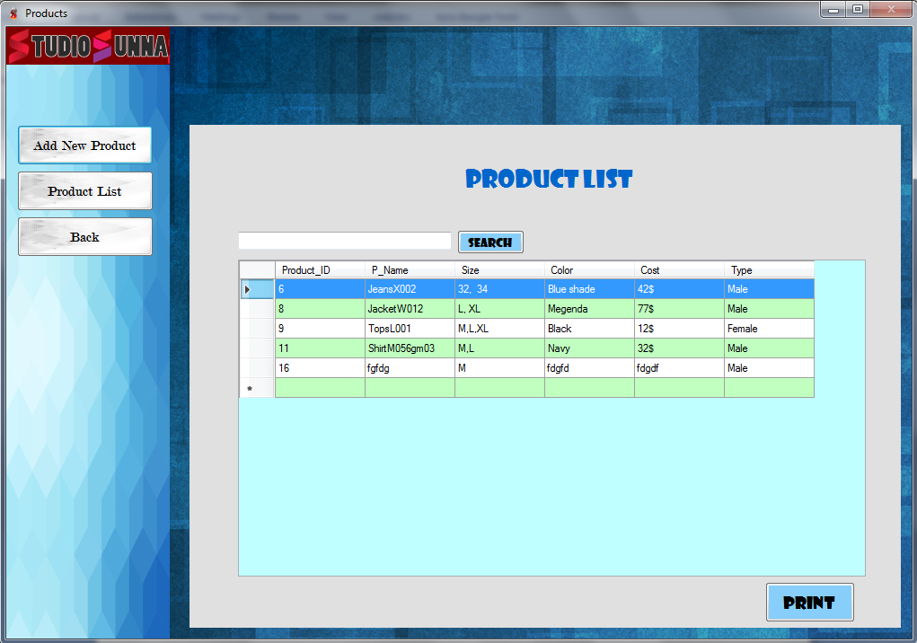

**Product-Add New Product**

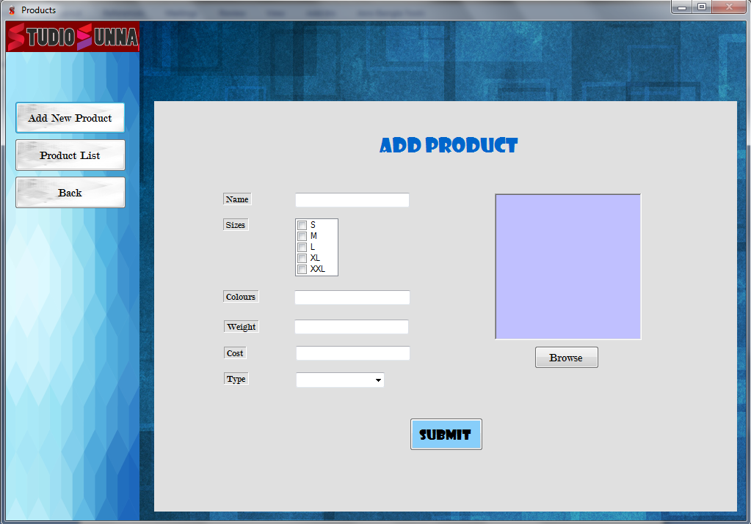

**Product- Product Details**

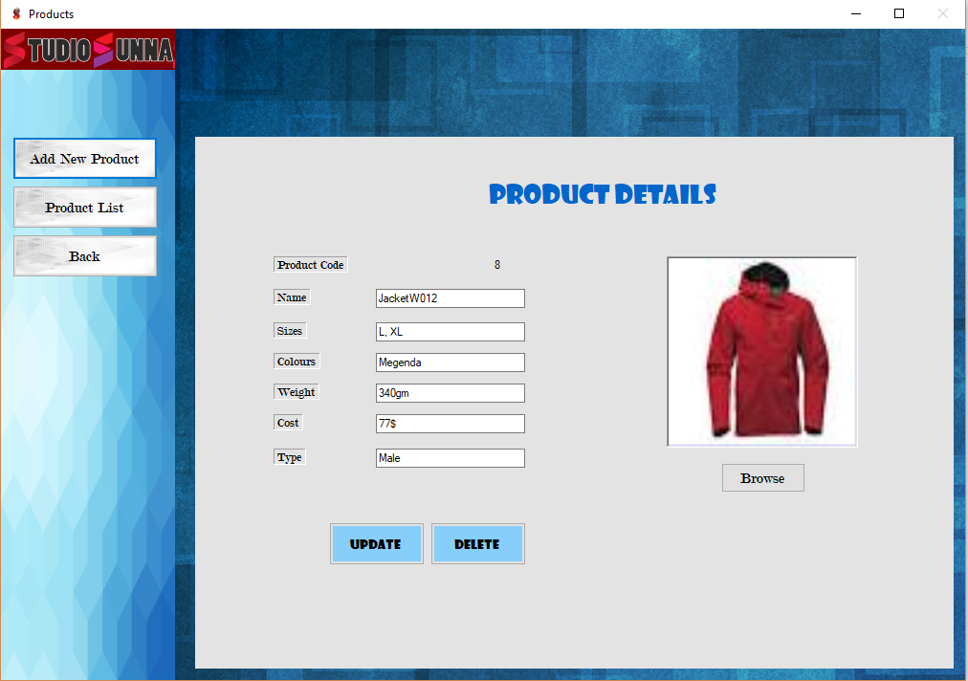

**Order-Order List**

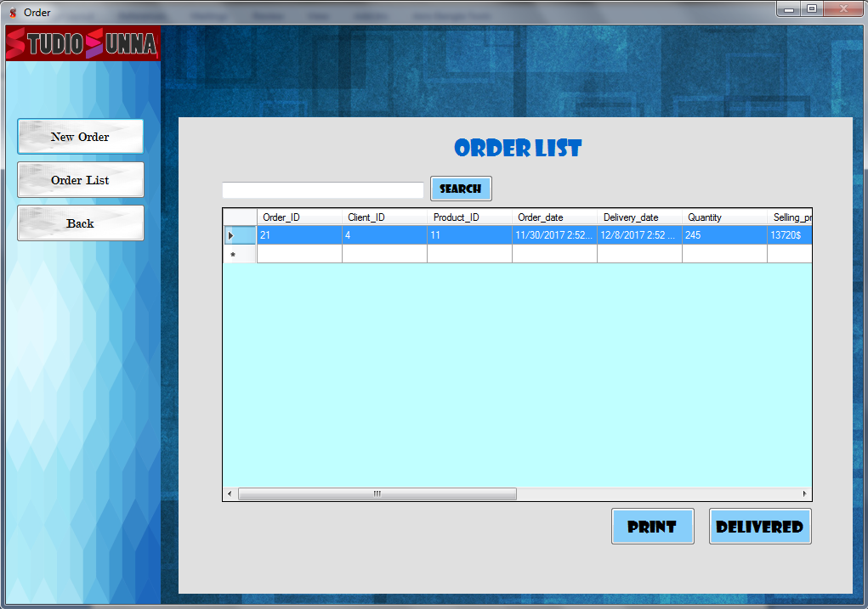

**Order-New Order**

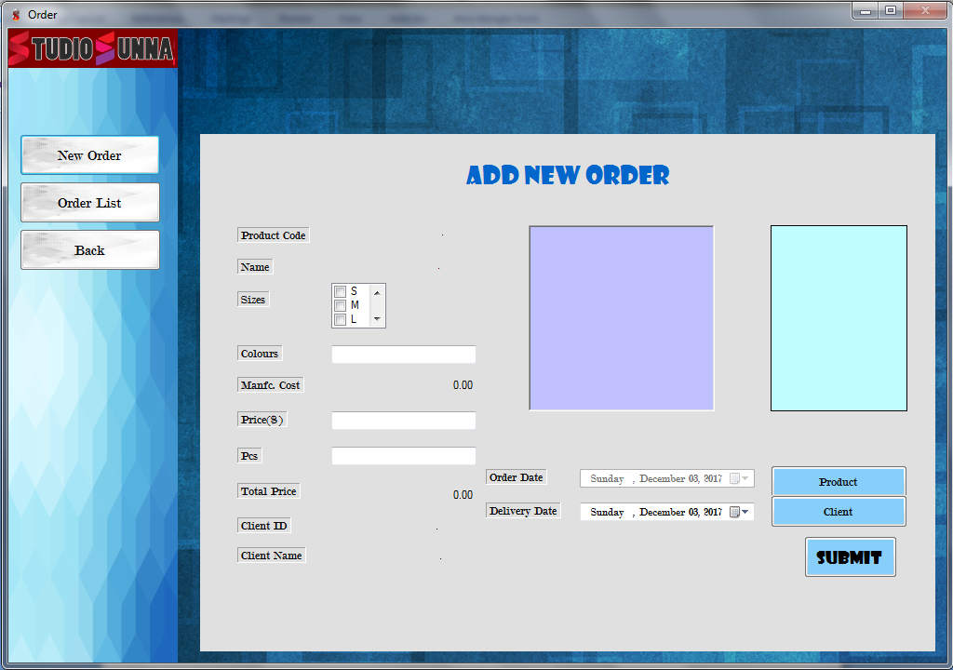

**Order- Order Details**

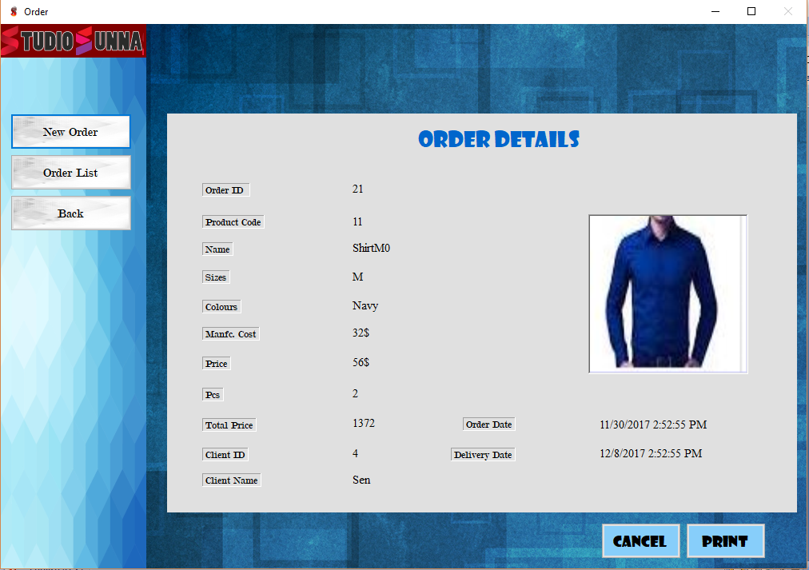

**Sales Record**

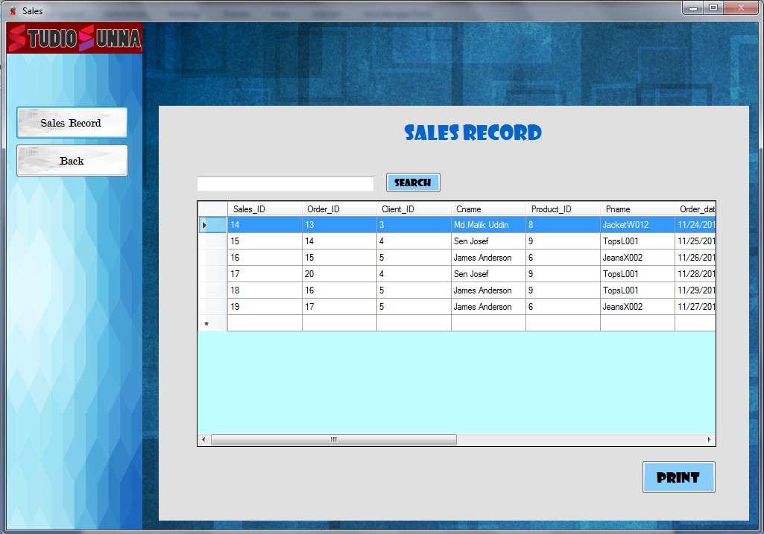

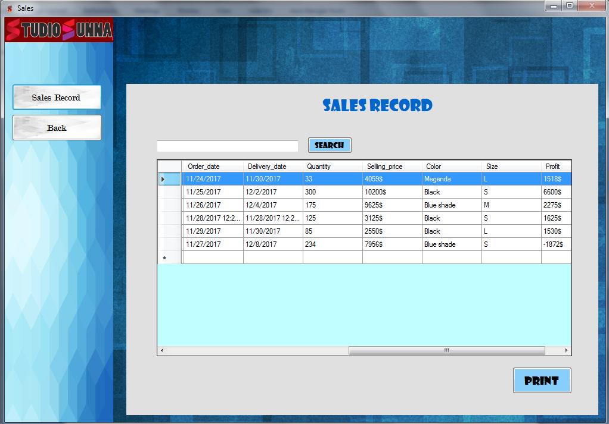

**Sales Record- Sales Details**

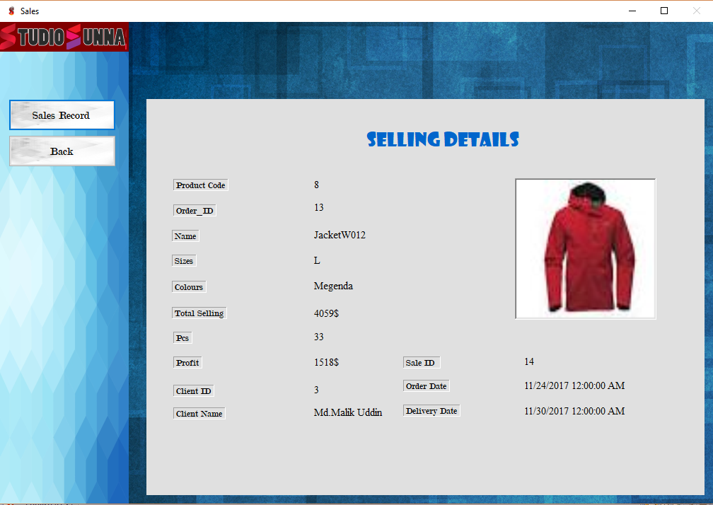

**Financial Report**

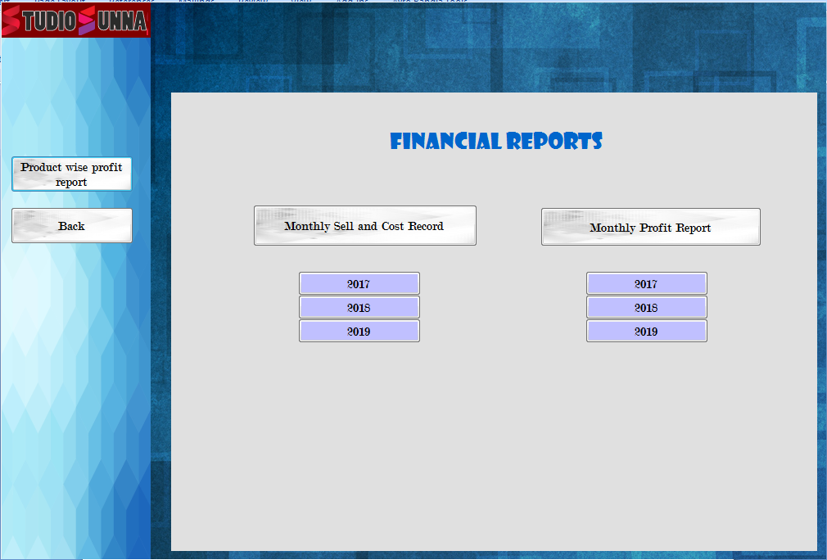

**Financial Report-Monthly Sell and Cost**

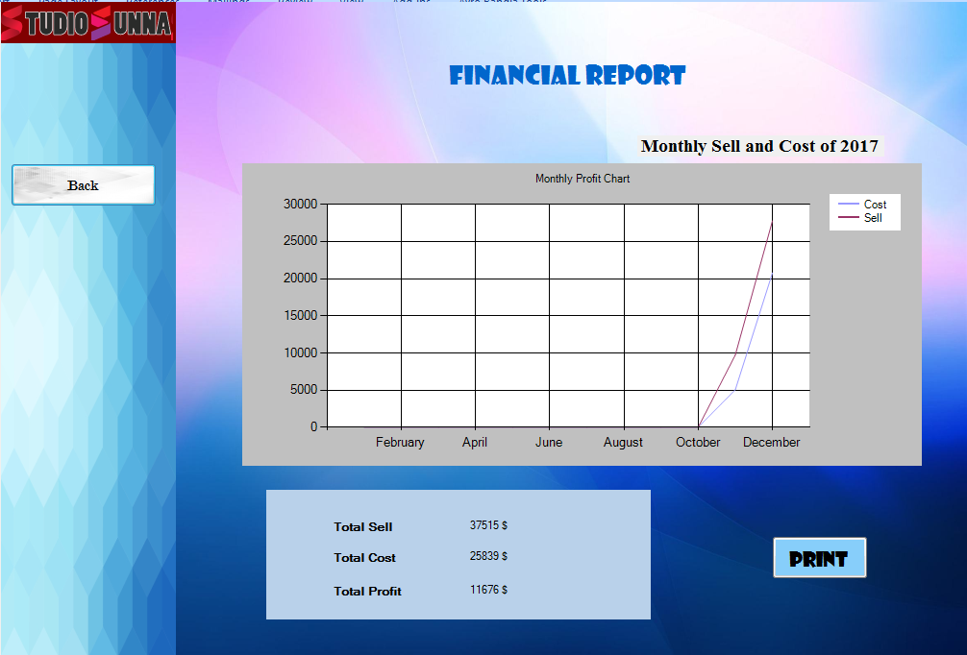

**Financial Report-Monthly Profit Report**

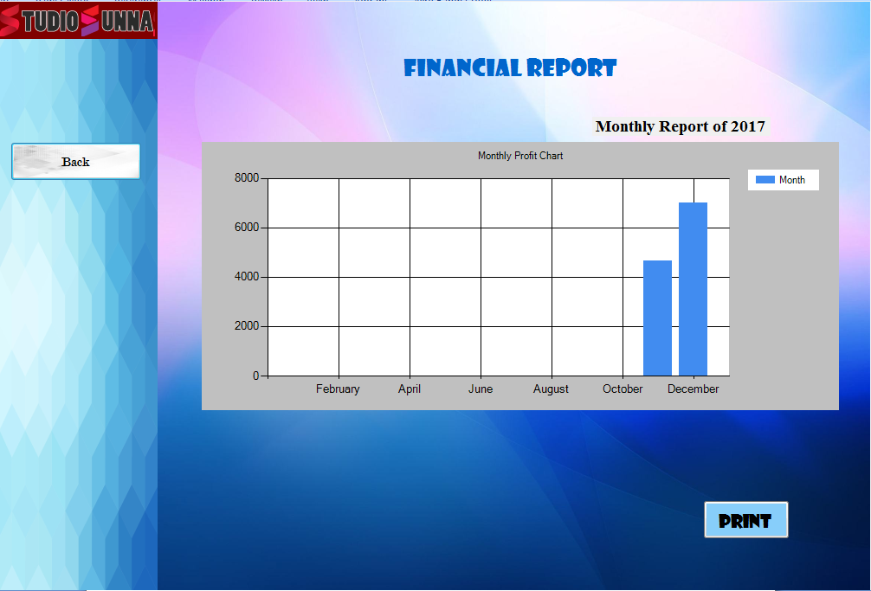

**Financial Report- Product wise Profit Report**

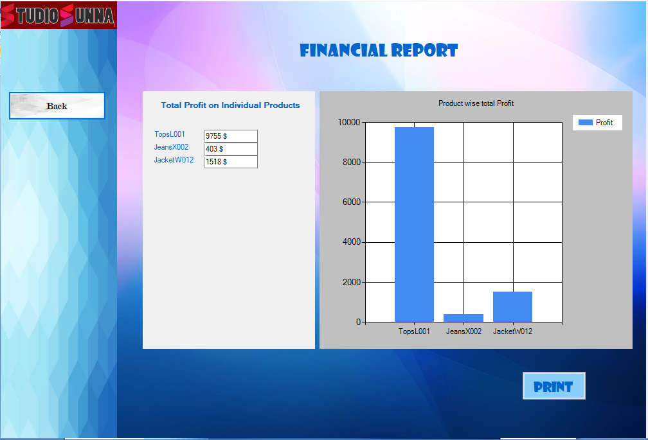

**Print PDF- Product wise profit Report**

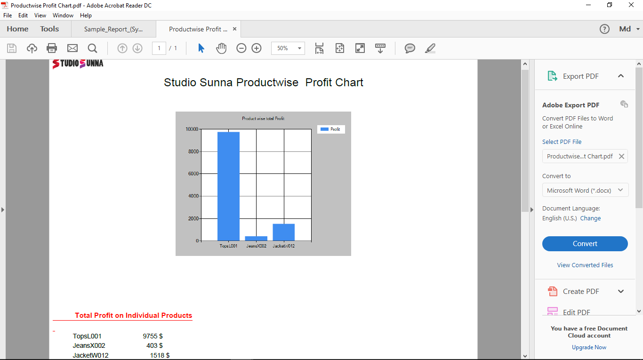

**Print PDF- Product list**

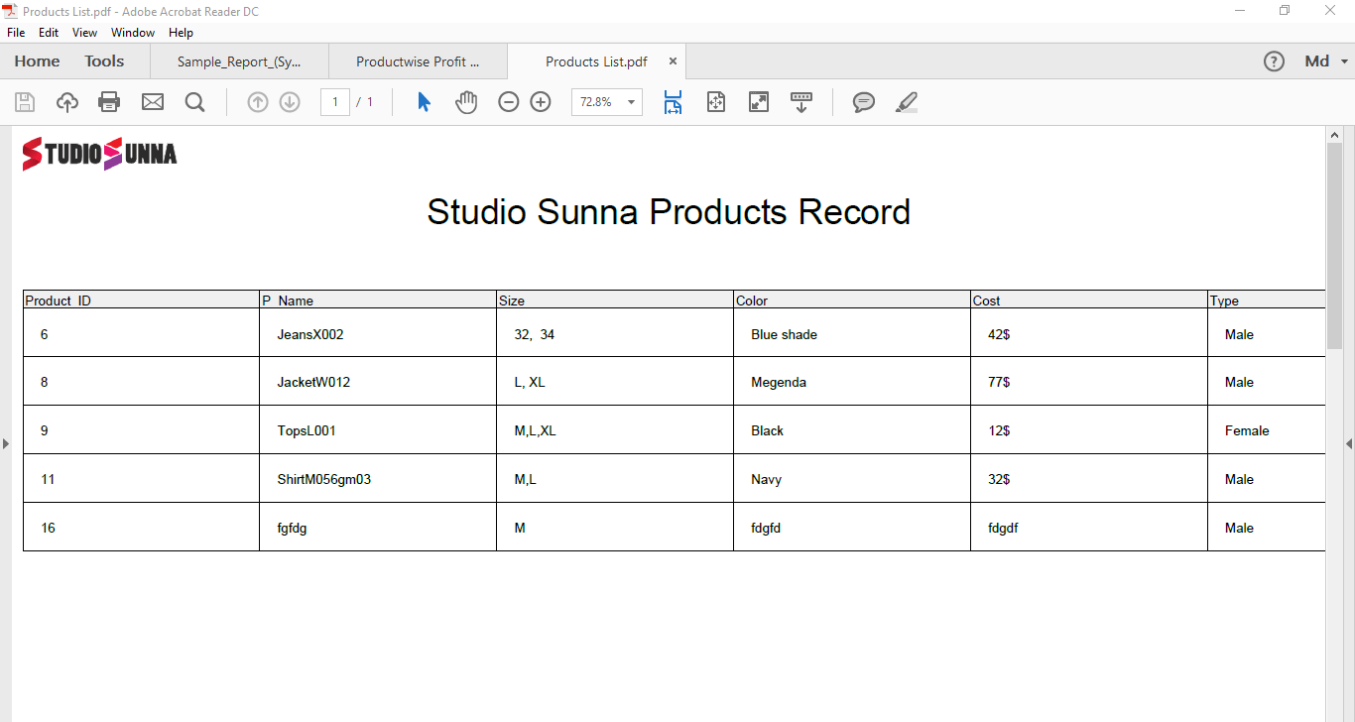

**Print PDF- Order list**

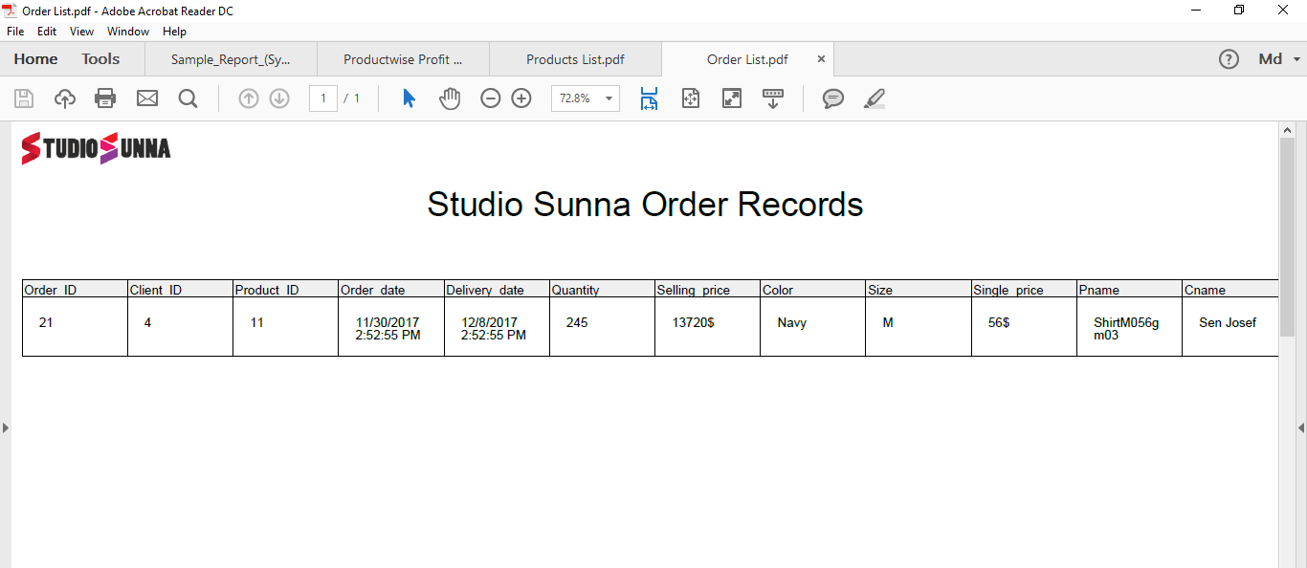

**7. Conclusion**

"Product Management System" keeps the day by day record. It can keep the information of clients, products, sales, financial records. It can visualized all the financial state in a better way. It can consume time as well as energy. We have tried our best to create a useful system for Studio Sunna.